Register Vs Auto Storage Class
Have you ever wondered how a simple C/C++ statement "count++;" is executed?

Typically, it's a three-step process (depends on CPU architecture):
Step 1: Copy the value of count from RAM (stack or data section) into a CPU register.
Step 2: Increment the value of the CPU register.
Step 3: Write the value of the CPU register back to that RAM location.

As you may know, RAM is slower than the CPU. More time is spent transferring data between RAM and the CPU than the actual increment operation.

To speed up execution, you might consider declaring the "count" variable as "register." This tells the compiler to place the variable in a CPU register instead of RAM. However, this request is granted only if a CPU register is available (note that the number of CPU registers is limited). In this case, you'll observe better execution speed as data transfer between CPU and RAM is skipped. If no CPU register is available, the variable is simply treated as a local variable and placed in the stack section.

The "register" storage class is similar to the "auto" (local) storage class, except for its storage:
Keyword: register
Default value: garbage
Storage: CPU register
Life: block
Scope/Visibility: block
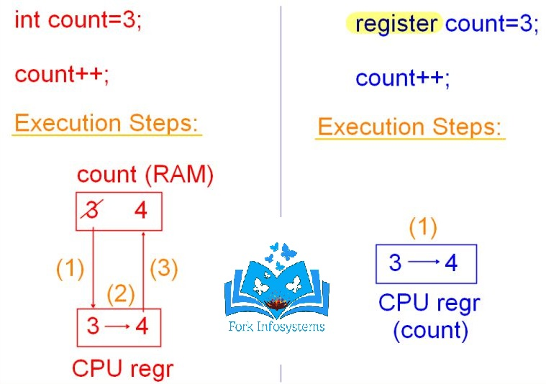

Some additional points about the "register" keyword:
1. "Register" variables are not addressable, meaning you cannot use the address of (&) operator with them.
2. IMPORTANT: Even if a variable is not declared as "register," the compiler may store it in a CPU register for optimization if it's accessed frequently. Most modern compilers do this.
3. The C'99 and C'11 standards deprecated the explicit use of the "register" keyword, considering compiler optimization. Now compilers may choose to ignore the "register" keyword or prompt a warning.

Have I missed any points regarding the "register" keyword?
Stay tuned for upcoming posts on "volatile."

